HARDWARE: the physical components of a computer system that you can see and touch.  An input device is any piece of computer hardware used to provide data to a computer system.  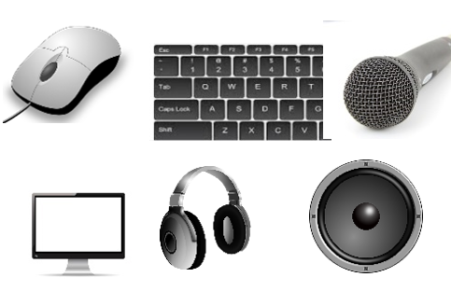  An output device is any piece of computer hardware that displays information (data that has been processed) in a human readable format. This could be as an image, sound, vibration or motion.  Some devices can be classed as both input and output devices, such as touch screen monitors and headsets.  Examples of manual input devices include: Mouse, Touchpad, Joystick, Concept keyboard.  Examples of automatic input devices include: Bar code reader,  Optical mark reader (OMR), Magnetic Ink Character Recognition (MICR) | KEYWORDS  Try and complete the keyword table in your OneNote  book at the end of each lesson.  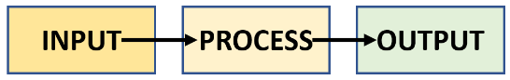  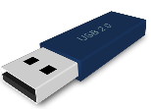  STORAGE DEVICES: computer hardware used to store data. Examples include hard disk drives, DVD and CD drives. Storage devices can be classed as internal or external devices.  Flash memory is solid-state storage used in a range of devices including USB memory sticks and gaming hardware. | SOFTWARE: the programs and other operating information used by a computer or digital device. Computer software can be divided into different categories, including:  - System Software: this includes the operating system of a digital device    - Application Software: everyday apps and programs you use, such as Microsoft Word, web browsers and games  - Utility Software: such as anti-virus software and file conversion software  - Bespoke Software: tailor made software intended for a specific job, for example, running an MRI scanner or a specialised booking system for a company    The Internet of Things: Computers and digital devices can connect, exchange and collect data with each other via the Internet.
  data | hardware | software
  fetch | decode | execute
  binary | Denary | ASCII
  input device | storage device | output device
  globalisation | connectivity | IoT
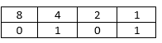
ASCII code takes each character on the keyboard and gives it a binary number. ASCII code can only store 128 characters which is enough for most words in English but not enough for other languages.
‘a’ = binary number 0110 0001

BINARY - a number system
that only two digits: 1 and 0.
All information that is processed by a computer is in the form of a sequence of 1s and 0s. The binary system is known as a ‘base 2’ system.
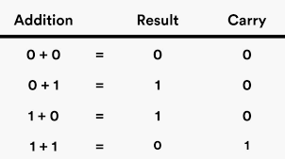
The Central Processing Unit
The CPU or microprocessor is considered to the brain of a computer. The CPU carries out processes such as calculating, sorting and searching. The CPU will execute sequences of instructions (called a program) – needed to process data on our digital devices. CPUs are found in a range of devices from computers, to washing machines and mobile phones.

Computer clock speed is measured
in hertz (Hz). A CPU with a clock rate of 1.8 GHz
can perform 1,800,000,000 clock cycles
per second!
1BBCBitesize


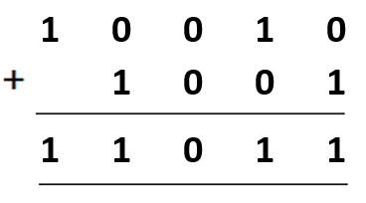
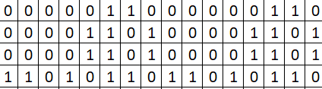
There are only 10 types of people in the world:
Those who understand binary and those who don’t
Binary Addition
https://icon-library.net/icon/icon-running-3.html

