 | Question | Answer
1. | 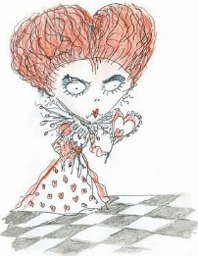  How would you describe the work of Tim Burton? | No right or wrong answer – purely subjective  Monotone, sad colours, desatuated colours, Messy, rough scratchy style
2. | Tim Burton states, ‘his work and films are all about the light and dark aspects of life and that one cannot live without the other’. Explain what you think Tim Burton means by this. | Burton has stated that his films look at both the dark and light sides of society, as it intrigued him that people so often ignored the darker side – what would be taboo issues in society e.g. death, murder, normalisation, etc.​  Burton would question – ‘who are we to say what is normal or not?’.
3. | What are the common features of Tim Burton portraits? | - Enlarged eyes.​  - Lots of shadows around the eyes​  - Exaggerated hair – the crazier the better!​  - Stringy limbs.
4. | What is stop motion animation? | Stop motion is an animated filmmaking and special effects technique in which objects are physically manipulated in small increments between individually photographed frames.
5. | What methods can you use to create tone with a biro? | Stippling, cross hatching, hatching
6. | Create a tonal chart using a Tim burton colour palette | 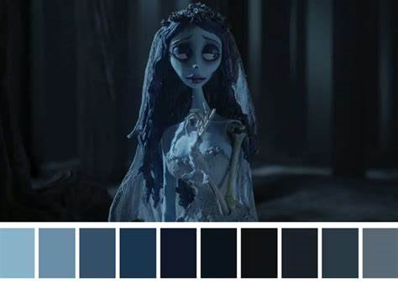
7. | What is a hue? | Pure colour that hasn’t been brightened or darkened.
8. | What is a tint? | The addition of white to lighten a hue creates a tint.
9. | What is a shade? | The addition of black to darken a hue creates a shade.
10. | What are adjacent colours? | Adjacent colours sit next to each other on the colour wheel and blend well together.
OBHS Core Questions:
Subject: Art
Year and Term: Year 7 Spring term
Topic: Tim Burton
Learn these questions to build a strong foundation of knowledge for this half-term. Ask family or friends to test you regularly, or practise on your own using the ‘Look, Say, Cover, Write’ method.

