 | Question | Answer
1. | What is a hue? | Pure colour that hasn’t been brightened or darkened.
2. | What is a tint? | The addition of white to lighten a hue creates a tint.
3. | What is a shade? | The addition of black to darken a hue creates a shade.
4. | What are adjacent colours? | Adjacent colours sit next to each other on the colour wheel and blend well together.
5. | What is composition? | The arrangement of the formal elements to complete a whole
6. | What is the rule of thirds? | A rule that ensures a composition is never split in half, either vertically or horizontally, nor with the main focus right in the centre like a bull's-eye.
7. | 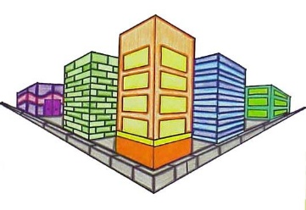  Which style of drawing does this show? | 2 point perspective
8. | 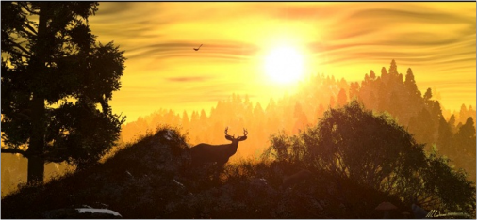  Label the background, foreground and midground | 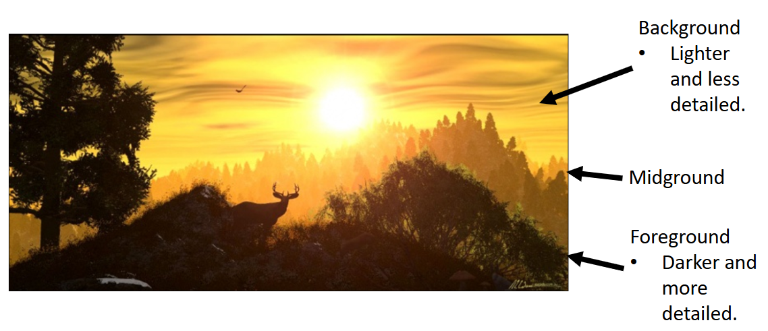
9. | 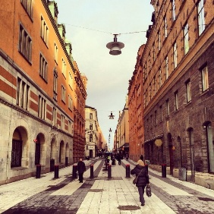  Which style of drawing does this show? | 1 point perspective
10. | What was the name of the artist who could see sound and hear colour? | Wassily Kandinsky
OBHS Core Questions:
Subject: Art
Year and Term: Year 8 Spring term
Topic: Perspective drawing
Learn these questions to build a strong foundation of knowledge for this half-term. Ask family or friends to test you regularly, or practise on your own using the ‘Look, Say, Cover, Write’ method.

