 | Question | Answer
1. | 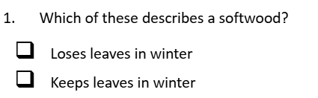 | Keeps leaves in winter
2. | Which softwood is suitable for outdoor use? | Larch
3. | Which hardwood is suitable for sporting equipment? | Ash
4. | 4Which hardwood is suitable for model making? | Balsa
5. | Which drawing style uses 45-degree angles? | Isometric
6. | Which saw did we use to cut plywood? | Coping saw
7. | Which timber joint did we use to join out key racks at a 90-degree angle? | Dowel joint
8. | Which 2 surface finishes did we use on the key racks? | Paint and wax
9. | All ferrous metals contain what? | Iron
10. | The ability of a material to deform without cracking describes the materials what? | Malleability
11. | The ability to of a material with withstand indentation and scratching describes the materials what? | Hardness
12. | Is lead a ferrous or non-ferrous metal? | Non-ferrous
13. | Which category of metal is pewter? | Alloy
14. | How did we make the pewter keyrings? What is the process called? | Casting
OBHS Core Questions:
Subject: Design & Technology
Year and Term: Year 7 Spring term
Topic: Key rack and key ring
Learn these questions to build a strong foundation of knowledge for this half-term. Ask family or friends to test you regularly, or practise on your own using the ‘Look, Say, Cover, Write’ method.

