
OBHS Core Questions:
Subject: Science
Year and Term: Year 9 Spring Term
Topic: C2 Structure and Bonding

Learn these questions to build a strong foundation of knowledge for this half-term. Ask family or friends to test you regularly, or practise on your own using the ‘Look, Say, Cover, Write’ method.

Question | Answer
- What are the three types of chemical bond? | Ionic, metallic and covalent
- Which chemical bond forms when non-metals combined with metals? | Ionic
- Which chemical bond forms when non-metals join with other non-metals? | Covalent
- How many electrons in the outer shell of an element in group 7? | 7
- What charge do ions of group 2 elements have? | +2
- What charge do ions of group 7 elements have? | -1
- What is a covalent bond? | A shared pair of electrons between two atoms
- How does an ionic bond form? | Electrons are transferred from a metal to a non-metal, forming ions.
- What type of structure is represented here:  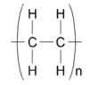 | Polymer
- What does (aq) show in a chemical equation? | Aqueous solution (the substance is dissolved in water)
- What state of matter are most polymers at room temperature? | Solid
- Which ionic structure can be represented in the following forms: 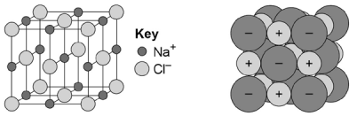 | Sodium chloride – giant ionic lattice
- What type of chemical bonding is represented in these diagrams?  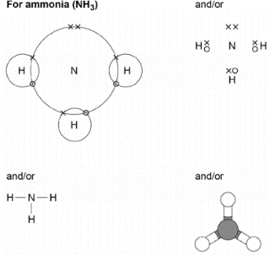 | Covalent
- What determines the amount of energy needed to melt or boil a substance? | The strength of the forces/ bonds between the particles
- State key properties of ionic compounds. | They have high melting and boiling points and they conduct electricity when molten or dissolved in water
- What forces acting between small molecules hold them together when liquid? | Weak intermolecular forces
- Name three examples of giant covalent structures that you need to know. | Diamond, graphite and silica
- What are the key differences between graphite and diamond? | Graphite is arranged in layers which can slide over each other, each carbon atom makes 3 bonds, there are delocalised electrons which can conduct electricity.  Diamond is much harder, each carbon atom makes 4 bonds, no free electrons.
- How are atoms arranged in pure metals? | Layers
- Which particles in metals allow them to conduct electricity and thermal energy? | Delocalised electrons
- How many covalent bonds does each carbon atom in diamond have? | 4
- How many covalent bonds does each carbon atom in graphite have? | 3
- Which material is a single layer of graphite and has properties that make it useful in electronics and composites? | Graphene
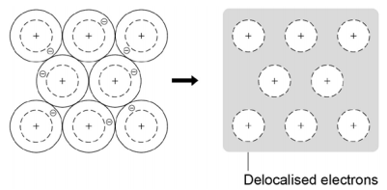  - Which type of chemical bonding can be represented in the following form: | Metallic
- Why can metals conduct electricity? | They have free electrons

