 | Question | Answer
1. | Give an example of an adjacent colour to yellow | Yellow to yellow orange to orange or Yellow to yellow green to green.
2. | Are adjacent colours low contrasting or high contrasting? | Low contrasting
3. | Are complementary colours low contrasting or high contrasting? | High contrasting (the highest contrasts on the colour wheel)
4. | Name three warm colours. | Yellow, Orange, Red
5. | Name three cool colours | Blue, Purple, Green
6. | 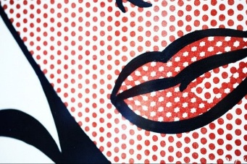  Which mark did Rot Lichtenstein famously use to create colour in comic books? | By intricately painting benday dots to create his colour
7. | Which 4 colours did Lichtenstein mainly use in his paintings? | Cyan, magenta, black and yellow
8. | “Everybody will have 15 minutes of fame in their lifetime” Who said that?  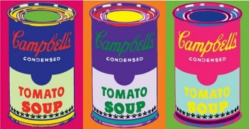 | Andy Warhol
9. | 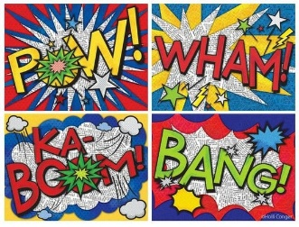  Onomatopoeia is used in pop art culture. What does this word mean? | Onomatopoeia is defined as a word, which imitates the natural sounds of a thing. It creates a sound effect that mimics the thing described, making the description more expressive and interesting!
10. | 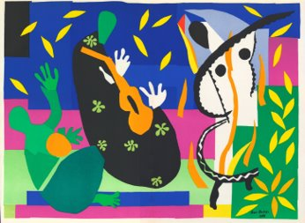  Which artist adopted the technique of ‘painting with scissors?’ | Henry Matisse
OBHS Core Questions:
Subject: Art
Year and Term: Year 7 Summer term
Topic: Pop Art
Learn these questions to build a strong foundation of knowledge for this half-term. Ask family or friends to test you regularly, or practise on your own using the ‘Look, Say, Cover, Write’ method.

