 | Question | Answer
1. | Which artist uses collage to create unique creates, animals and monsters to illustrate her story books? | Sara Fanelli
2. | What is the name of the technique used to layer and stick paper on top of each other? | Collage
3. | What is the technique Sgraffito? | Scratching through a surface layer to reveal a lower layer in a contrasting colour.
4. | What is an anatomy drawing? | Anatomical drawing refers to the detailed representation on the body, focusing on its structure and proportions. This art form emphasizes the correct placement and relationships of muscles, bones, and other body parts, which is essential for creating realistic figures in art
5. | What is an accent colour? | A secondary colour used to compliment a primary colour scheme or palette. They should draw attention.
6. | What could you do to acrylic to help create shadow and shade? | Water it down
7. | Why do we need to cover clay in wet paper towels? | To keep it moist until we have finished sculpting
8. | What is the definition of sculpture? | Three-dimensional art made by one of four basic processes: carving, modelling, casting, constructing
9. | Name a tool you would use when carving? | Chisel and sandpaper
10. | If a Sculpture is not fixed to the wall or ceiling, what is it called? | Free standing
11. | 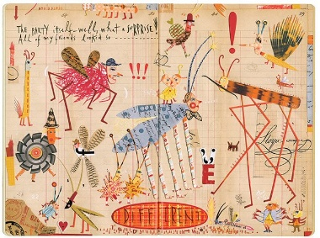  How do you think Sara Fanelli made these images? | Lots of everyday items and imagery combined together to make an abstract looking children’s book.
OBHS Core Questions:
Subject: Art
Year and Term: Year 8 Summer term
Topic: Mythical creatures
Learn these questions to build a strong foundation of knowledge for this half-term. Ask family or friends to test you regularly, or practise on your own using the ‘Look, Say, Cover, Write’ method.

