 | Question | Answer
1. | What does distortion mean? | To distort an object in art means to change its shape in some way.
2. | Suzanne Sardoff used what in her artwork? | Still life
3. | 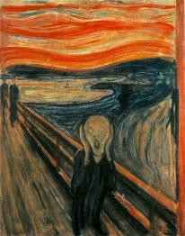  Who’s artwork is this? | Edvard Munch
4. | What is the name of the artistic movement that portrayed the essence of an object by displaying it from many different angles and points of view? | Cubism
5. | Who were the two key founders of the Cubist Movement? | Pablo Picasso and George Braques
6. | What is the difference between Analytical and Synthetic Cubism? | Analytical Cubism was focused on the analysis and perception of an object. Synthetic Cubism was focused on the construction of an object. (Analytical = Recreation / Synthetic = Creation.
7. | What is the key technique used for Synthetic Cubism | Collage
8. | Did the Cubism artists use traditional one point perspective in their work? | No
9. | What main colours did the analytical Cubists use, dull or bright? | Dull
10. | Was it Analytical Cubism or Synthetic Cubism that used tone mostly? | Analytical
OBHS Core Questions:
Subject: Art
Year and Term: Year 9 Summer term
Topic: Distortion
Learn these questions to build a strong foundation of knowledge for this half-term. Ask family or friends to test you regularly, or practise on your own using the ‘Look, Say, Cover, Write’ method.

