OBHS Core Questions:
Subject: Design & Technology
Year and Term: Year 8 summer term
Topic: Moving toy
Learn these questions to build a strong foundation of knowledge for this half-term. Ask family or friends to test you regularly, or practise on your own using the ‘Look, Say, Cover, Write’ method.
 | Question | Answer
1. | List the 4 types of motion | Linear, rotary, oscillating, reciprocating
2. | Which type of motion can you identify for these products?  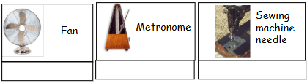 | Fan – rotary  Metronome – oscillating  Sewing machine needle – reciprocating
3. | Which type of motion do all vehicles move in? | Linear
4. | Identify the class of lever for each image below  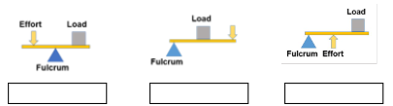 | Class 1  Class 2  Class 2
5. | Which class of lever do you see on the products below?  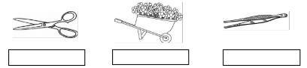 | Class 1  Class 2  Class 2
6. | A bicycle wheel rotates 190 times over the course of 75 seconds. What is the revolutions per minute? | 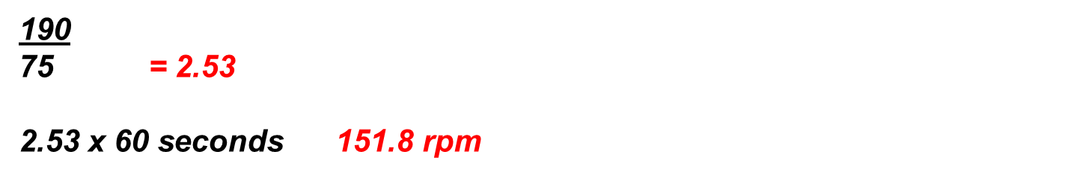
7. | A car travels 60 miles for 2 hours. What was the speed for the journey in miles per hour? | 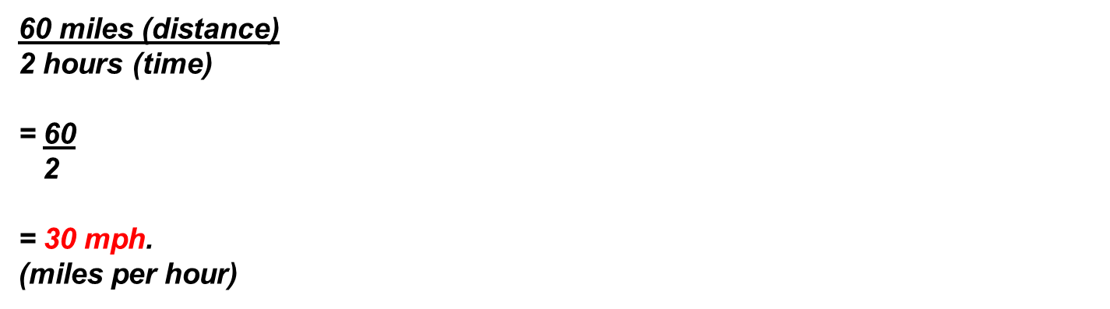
8. | A car travels to London from Norwich, which is a total of 118 miles. Travelling at 65mph, how long would it take to travel the journey? | 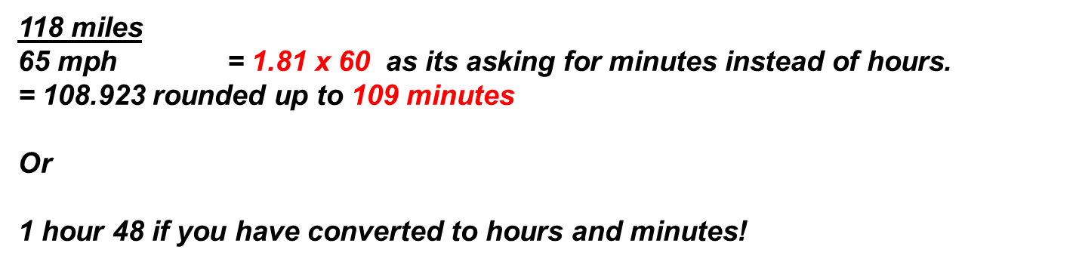
9. | Identify the following CAMS?  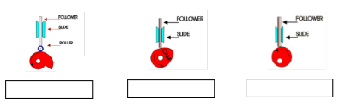 | Snail  Pear  eccentric
10. | Which rotary system is this?  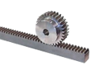 | Rack and pinion
11. | Work out the gear ratio on the gear trains below.  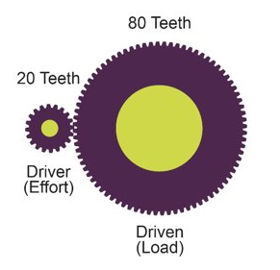  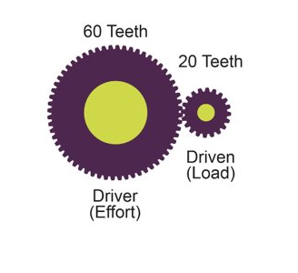
12. | 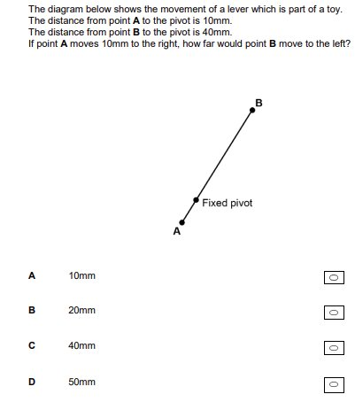
13. | 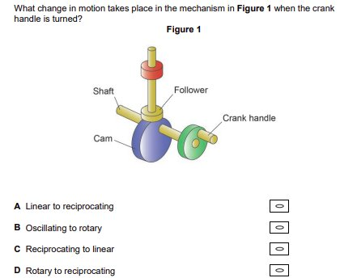
14. | 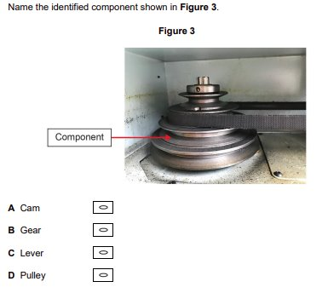
15. | 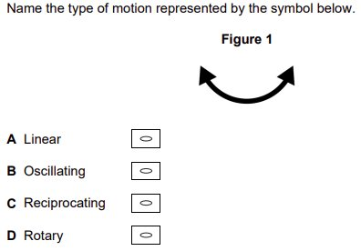
16. | 