
OBHS Core Questions:
Subject: Food and nutrition
Year and Term: Year 11 Summer term
Topic: Exam questions
 | Question | Answer
1. | 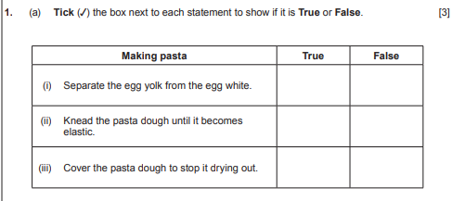 | 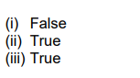
2. | Name two ingredients that could be added to change the colour of the pasta. | beetroot • tomato/tomato puree/ketchup • spinach • squid ink/cuttlefish ink • herbs • spices (e.g., saffron/paprika/turmeric) • carrot puree • red cabbage • broccoli • egg • orange/red/green peppers • wholemeal flour / bran • chocolate / cocoa powder
3. | 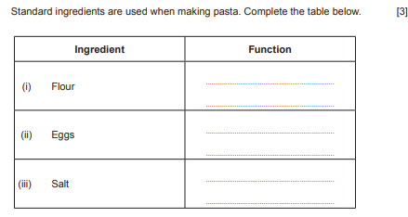 | 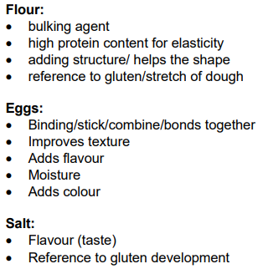
4. | 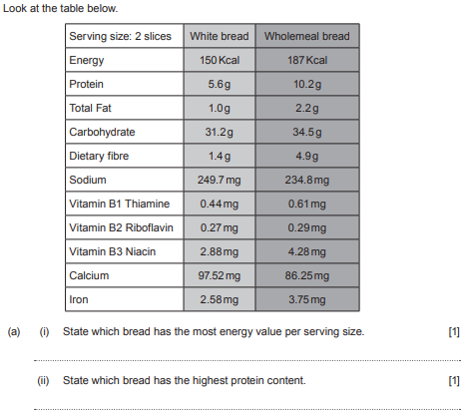 | - Wholemeal bread  - Wholemeal bread
5. | Describe why wholemeal bread has more dietary fibre (NSP) content than white bread. | Wholemeal flour is made from the whole wheat grain/ 100% extraction rate. • Wheat bran provides dietary fibre as it contains the whole grain/bran layer • White flour has most of the bran and wheat germ removed, so it is lower in fibre
6. | A baker has produced a batch of bread rolls which are heavy and small. Give two reasons why this has happened and suggest how this could have been avoided. | Reason: • Yeast is not active/yeast out of date • Not enough CO2 produced • Mixing yeast and salt together • Not enough liquid so the dough cannot expand with steam • Not enough liquid added • Proving time too short. • Wrong flour used /Protein content in flour too low. • Dough under-kneaded / insufficient kneading / longer kneading required • Yeast killed – water too hot • Not enough yeast How this can be avoided: • Ensure that 37⁰C liquid is used during fermentation/warm liquid used/ use water at right temperature / hand hot /tepid • Liquid hydrates yeast – so must measure liquid and follow recipe • Use sufficient liquid to form correct dough consistency/soft sticky dough, enables the dough to stretch • Keep yeast and salt separate to prevent salt killing yeast/yeast becomes inactive • Liquid hydrates proteins (gliadin and glutenin) so ensure adequate used • Use Sugar as needed for food for yeast • Use Strong plain flour with high gluten content • Use enough yeast/ fresh yeast / quick action yeast • Adequate Proving of bread is needed to ensure starch present in the flour is broken down and fermented by the yeast. CO2 is produced and causes the gluten network to expand and make the dough rise. • Ensure adequate kneading of bread (8- 10mins) to develop gluten and stretch/elasticity.

7. | Obesity is a national health issue. Discuss the consequences of obesity. | Answers may refer to • Type 2 diabetes • cardiovascular disease/coronary heart disease • High blood pressure • some cancers • Gall stones • Osteo-arthritis / painful joints due to excess weight • Depression and mental health issues • As well as reducing both life quality and life expectancy Poor mobility - Physical activity is not always able to be completed, also linked to breathing difficulties • Obesity also has wider implications • Skin sores/rashes due to excess folds of skin • Additional costs for society /NHS .
8. | Explain the difference between the two types of cholesterol. | Low – density lipoprotein (LDL) Bad cholesterol (1) LDL Transports cholesterol to body cells but does not take excess amounts back to the liver. Instead the excess cholesterol is deposited in nether artery walls and forms atheroma. For an adult 3mmol/L or lower Causes heart attack/stroke Raised by consumption of saturated fats (1) and maybe lowered by soluble fibre in oats (2) Can cause heart issues – heart attacks High – density lipoproteins (HDL) Good cholesterol (1) Lot of protein, little fat Omega 6 HDL transports cholesterol away from body cells and back to the liver where it is either removed as a waste product or broken down. Lower risk of heart disease and stroke
9. | Name two functions of protein in the diet | • Growth • Repair (body cells and tissues) renewal of cells • Maintenance • Production of hormones, enzymes, antibodies • Secondary source of energy/excess protein used as energy source • Maintain muscle mass
10. | Give three reasons for cooking food. | • Make food safe to eat/kill micro-organisms • Add variety to our diet • make food smell more appetizing • change colour of food to make more appealing • enhance the flavour of the food • Make food hot / heat it up • Easier to eat/bite/chew/digest/ make food softer so that it is more palatable • improves texture of foods • Improve nutritional value (grilling)/ fat runs out so healthier • Can preserve food and make it last longer/ improves shelf life
11. | Cooking can transfer heat energy to food in different ways. Describe how heat energy is transferred when: (i) Grilling bacon. | • Heat energy is passed directly from the grill to the bacon by (waves of) radiation • Waves are absorbed by the bacon and heat it up • Conduction – from the pan / through the foods
12. | Outline the process of blanching. | • Blanching is a short heat treatment/scalding vegetables in boiling water or steam for a short time • Vegetables • Kills surface micro-organisms/inactivates enzymes which can cause loss of flavour, colour and texture • Boiling water 2 mins • Blanching time depends on size of vegetable/surface area. • After heat, quickly putting it into cold/iced water • Halts the heating process
13. | Describe the effect of cooking on meat | Answers could refer to • Protein coagulates between 40’C and 60’C. • Meat muscle shrinks. • Moisture is lost/ juices released • The fat melts /renders • Colour changes depending on method of cooking. red to brown (1) / pink to white (1) • Vitamin B loss in moist methods of cooking. • Collagen softens and is broken down/ converted to gelatine/ tenderises in moist cooking method. Increases tenderness of meat and makes it more digestible Decreases nutritional value of meat • Meat undergoes the Maillard reaction as the meaty flavour is developed or as meat goes brown • Meat protein denatures – muscle fibres become firmer and meat juices are squeezed out • In dry methods juices are lost from the surface leaving a more concentrated meat flavour on the surface. • Improves texture
14. | Micro-organisms are transferred by cross-contamination. Discuss how cross-contamination can occur when making a chicken and bacon salad and describe the methods of control that can be used to ensure food safety. | Sources of contamination: • Contaminated food (raw chicken/bacon/salad ingredients) • Contaminated work surfaces • Contaminated utensils (knives. chopping boards, scissors) • Contaminated equipment (salad spinners, chopping boards, dirty tea towels) • People (poor personal hygiene, hair, jewelry, coughs and sneezes, nails, wounds/ blue plasters • Don`t wash chicken • incorrect storage causes – blood/juices dripping onto other foods  Methods to prevent cross contamination • Separate raw and cooked foods • wash salad ingredients thoroughly • Anti bac/sanitize/disinfect surfaces/ and thoroughly cleaning/wiping down surfaces with hot soapy water/paper towels/ clean cloths • Use different utensils (different knives for prepping each ingredient, no double dipping when tasting foods) • Use coloured of boards eg red raw meat/yellow cooked /green salad etc • Check date marks and ensure good stock rotation /FIFO. • Use different equipment (coloured chopping boards, clean tea towels, hand washing routines and paper towels) • Cover all food when its not in use • Prevent pests/insects landing on food • Keep pets out of the kitchen • Wash hands frequently eg prior to starting to prepare the food, after handling raw chicken/bacon • Do not touch face/hair and wear a hairnet/beard net/gloves when preparing food • Wear a clean apron/overalls to avoid spreading of germs/dirt • Cover cuts/sores/wounds/ blue plasters • Keep chicken/bacon in fridge until needed • If chicken is pre-cooked it should be kept in a sealed container in fridge 5c – not bottom shelf • If chicken is to be cooked – store in fridge on the bottom shelf • If mayo is used it should be kept in the fridge • Place the completed salad into the fridge asap • Wrap the plate of salad with cling [or equivalent] before refrigerating
15. | Discuss the influences cultural and lifestyle changes have had on food choice and availability | Answers could refer to • a time poor society • globalisation • multi-cultural society / increased ethnic population travel experiences • Lifestyle changes – age/work/ stage in life eg starting a family/ eating habits e.g. vegetarians / obesity • people want healthier choices • Medical – recognised /diagnosed allergies eg lactose intolerant/coeliac disease-/diabetes necessitate-lifestyle changes Examples of influence could include • ready meals (which reflect these influences)/ example • Shopping for convenience • Consumers want more variety • Ethnic influence with typical associated food (product) (e.g. Mediterranean influence – pasta dishes, olive oil, herbs) • snack products (which reflect these influences)/ example of • fusion foods / hybrid foods • import of exotic foods/ traditional foods from other countries • British /regional foods • food assembly kits – Hello fresh/ Gousto • takeaway ranges • dining-in range • pop-up restaurant • ‘on the go’ food • Meal habits related to patterns in culture (timings/style of food eg tapas, grazing habits). • Street food • foods to celebrate customs /festivals/religious celebrations • Using Halal meat in products to supply needs of Muslim community, Kosher food for Jewish culture • Wide variety of different bread products • Positive dietary influences from ethnic diets e.g Mediterranean diet promoted as being better for heart health/ any correct example • Increased understanding of and interest in vegetarian and vegan recipes/ meat free Monday’s • Celebrity chefs promoting products using ethnic ingredients • Social media influences – Instagram/ Facebook etc  Influence of TV shows- Masterchef/Bake off etc on food preparation and cooking • Opening of many shops specialising in ethnic ingredients for immigrant communities • Luxury market • Pandemic/lockdown restrictions/CV19 o availability of food/shopping/deliveries/ o communities supporting each other. • restaurants from different cultures-eg Turkish/Polish

