Signposting and support

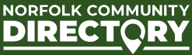
The Norfolk Community Directory is a resource that provides residents and families with information, advice, services, and activities across Norfolk. It aims to help residents live healthy, active, and fulfilling lives by offering details about various activities, services, and groups available in the area.
https://communitydirectory.norfolk.gov.uk/
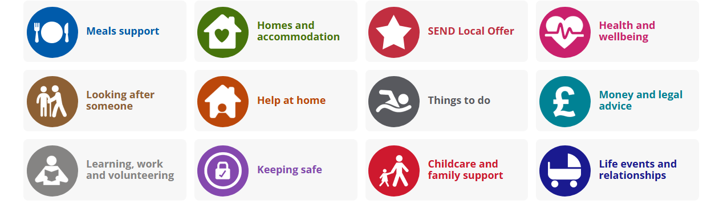
-----------------------------------------------------------------------------------------------------------------------

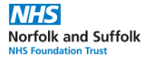
Up-to-date advice and guidance on how parents and carers can support the wellbeing and mental health of their children.
Parent workshops | Norfolk and Suffolk NHS
----------------------------------------------------------------------------------------------------------------------

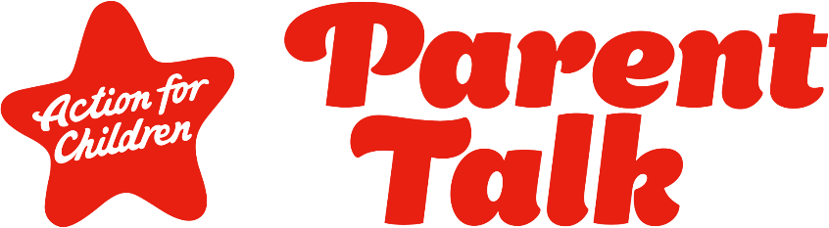

Free parenting support on webchat and WhatsApp - Parent Talk

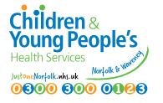
Just One Norfolk is where families can go to access Mental Health services and Neurodevelopmental support for children and young people aged 0-25. You can contact the Just One Service with any questions or concerns about your child's health, wellbeing or development.
https://www.justonenorfolk.nhs.uk/
If your child is feeling worried about going to school, or you are struggling with their attendance here are some tips to work through together.
School Anxiety Tips
------------------------------------------------------------------------------------------------------------------------

YoungMinds is a mental health charity in the UK dedicated to supporting children, young people, and their parents. The organization aims to ensure that all young people can access the mental health support they need, providing a range of information, advice, and resources for those affected by mental health issues. YoungMinds also empowers young people to take care of their mental health and helps parents and carers with tips and advice.
https://www.youngminds.org.uk/

Kooth is a free, safe and anonymous online chat and emotional wellbeing service for young people aged 11 to 25, across Norfolk. Kooth is here for you when you need someone to talk to. If you are going through a hard time and you are not sure who to speak to, login to Kooth.
https://www.kooth.com/



Nelson‘s Journey supports children and young people in Norfolk who’ve experienced the death of a significant person. Since 1997, Nelson’s Journey has helped thousands of bereaved children and young people in the county.
https://nelsonsjourney.org.uk/

You can access mental health advice, support and counselling at MAP that’s free, confidential and carried out by trained professionals.
We can help if you are:
- Anxious, depressed or angry
- Feeling overwhelmed
- Struggling to cope with your emotions
- Finding day-to-day life hard to manage
- Troubled by difficult and painful experiences in your past
- Affected by specific issues like self-harm, discrimination, eating disorders, drug or alcohol addiction, or identity issues around gender or sexuality
- Looking to improve your self-esteem, relationships and quality of life

https://www.map.uk.net/
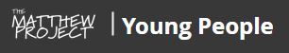
The Matthew Project is a Norfolk charity offering free, confidential support for young people dealing with issues around drugs, alcohol, or family substance use.
https://www.matthewprojectyoungpeople.org/

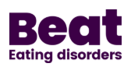
Struggling with an eating disorder? Caring for someone who is? Beat is here to support you.
https://www.beateatingdisorders.org.uk/
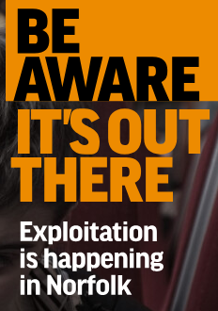
The Office for Police and Crime Commissioner for Norfolk are delighted to share their 'Know the Signs', a bespoke exploitation website covering all forms of exploitation relating to children, young people and adults in Norfolk.
https://knowthesigns.info/


Just One Norfolk
https://www.justonenorfolk.nhs.uk

Just One Norfolk
Call Just One Number on 0300 300 0123 or text 07520 631590 with any questions or concerns mental health, emotional health, Healthy lifestyles.

Daisy Programme | Support For Families
For young people who have witnessed domestic abuse within the family.

Young Carers and Families Support Norfolk | Carers Matter For students who care for parents or siblings or who are impacted by a member of their family having a long-term condition/illness.

Breckland YAB | MAP Norfolk
Young people having a say in their area. There is a YAB group who meet each week at OBHS.

Cup-O-T: Wellness and Therapy Services – A non-profit mental health service

