Pupil premium strategy statement – Old Buckenham High School

This statement details our school’s use of pupil premium funding to help improve the attainment of our disadvantaged pupils.
It outlines our pupil premium strategy, how we intend to spend the funding in this academic year and the outcomes for disadvantaged pupils last academic year.

School overview
Detail | Data
Number of pupils in school | 505
Proportion (%) of pupil premium eligible pupils | 29.10%
Academic year/years that our current pupil premium strategy plan covers (3-year plans are recommended – you must still publish an updated statement each academic year) | 24-25  25-26  26-27
Date this statement was published | December 2025
Date on which it will be reviewed | December 2026
Statement authorised by | Paul Beale (Head Teacher)
Pupil premium lead | Laura Boggis (Assistant Headteacher)
Governor / Trustee lead | Penny Sheppard  (Trust Lead)

Funding overview
Detail | Amount
Pupil premium funding allocation this academic year | £ 142,450.00
Pupil premium funding carried forward from previous years (enter £0 if not applicable) | £ 0
Total budget for this academic year  If your school is an academy in a trust that pools this funding, state the amount available to your school this academic year | £ 142,450.00

Part A: Pupil premium strategy plan

Statement of intent
The Education Endowment Fund recognises the importance of high quality teaching – identifying this as the single ‘most powerful way for schools to improve pupil attainment, especially for socio-economically disadvantaged pupils.’
“By identifying the challenges faced by disadvantaged pupils, using evidence to determine the most effective solutions, and carefully planning their implementation, schools can maximise the impact of their limited resources.” This philosophy forms the foundation of Old Buckenham High School’s commitment to supporting our Pupil Premium learners. Our ultimate goal is to ensure that disadvantaged students, like all our pupils, are equipped and empowered to achieve, whilst recognising the importance of our three underpinning principles of ‘Community, Ambition and Respect.’
Addressing the complex educational challenges within any school requires more than a single solution. We believe a comprehensive, multi-faceted approach provides the best opportunity for our students to thrive and that a ‘menu of approaches’ allows us to give tailored and holistic support to those facing disadvantage. It is important to recognise those facing disadvantage are not a homogenous group: Each student encounters unique academic and pastoral challenges. Our focus is on identifying and overcoming these barriers to learning, ensuring that students from disadvantaged backgrounds achieve success alongside their peers. This is achieved through:
- A broad and enriching curriculum that fosters personal and social development, confidence in learning, and cultural capital.
- Teaching strategies that inspire motivation, high aspirations, and accelerated learning for all.
- Tailored pastoral support.
- Targeted interventions to close achievement gaps and address barriers to learning and progress.
- Financial support to ensure equal access to enrichment opportunities, revision materials and in class materials for those experiencing hardship.
Our approach is grounded in principles outlined in the Ofsted research brief ‘Supporting the Attainment of Disadvantaged Pupils: Articulating Success and Good Practice’ (November 2015):
- Foster an ethos of high attainment for all pupils, avoiding stereotypes that limit the potential of disadvantaged students.
- Provide individualised support to address learning barriers and emotional needs early, rather than relying on generic interventions or focusing solely on pupils nearing key assessments.
- Prioritise high-quality teaching over supplemental strategies or activities conducted outside school hours.
- Focus on achieving positive outcomes for individual pupils rather than implementing one-size-fits-all strategies.
- Assign the most effective staff to support disadvantaged pupils, building the skills of teachers and TAs who know the students well, rather than relying on additional staff unfamiliar with their needs.
- Base decisions on data and respond to evidence, using frequent assessments and adaptable approaches rather than one-off evaluations.
- Demonstrate clear and proactive leadership, setting high aspirations and sharing the responsibility of raising attainment across all staff, while rejecting low expectations and inconsistent performance.

Challenges
This details the key challenges to achievement that we have identified among our disadvantaged pupils.
Challenge number | Detail of challenge
1 | Literacy.  2025-26: 32 PP students in Y7 – 9 of which have a standardized score of below 90 (ART Reading)  2024-25: At OBHS, we have recently transitioned to a new reading age assessment scheme and so our most recent data field is not yet complete or ready for analysis. Of our current Year 7 who have completed the new reading assessments, 11 of our 30 identified disadvantaged students have a standardised reading score below 90. However, historically OBHS has a legacy of disadvantaged students with poor literacy skills. The transition data provided from primaries showed that 25% of our current Year 9 students (2023-24) were not meeting expected levels for reading and 39% for writing on entry to KS3. Of which 32 students are PPG. This remained an ongoing trend in 2023 with 31% of our now year 8 students not meeting expected standard in English Reading upon entry. According to the EEF ‘a disadvantaged child in England is still more than twice as likely as their classmates from more advantaged homes to leave primary school without reaching the expected levels in reading and writing.’ Whilst the National Literacy Trust Annual Survey of 2024 states that only 1 in 3 young people enjoy reading in their spare time.
2 | Attendance.  2025-26: Since September 2025, Cumulative attendance for non-disadvantaged 94.44% vs disadvantaged 90.18%. Persistent absences for non-disadvantaged 11.84% vs disadvantaged 20.52%.This demonstrates that although improvements have been made to attendance overall, the gap between advantaged and disadvantaged remains a challenge.  For the academic year 24-25, attendance data was as follows:  2024-25: Since September, of non-disadvantaged students have a cumulative attendance of 93.31%, whilst our disadvantaged students have a cumulative attendance of 89.09%. Further exploration of these statistics show 34.56% of our disadvantaged students are classified as persistent absentees, compared to 16.62% of our non-disadvantaged students. Our disadvantaged PA rate is far in excess of the national average for all students: the most recent data release from the DfE stands at 19.2%. The EEF recognises the clear link between attendance and improving outcomes stating ‘With clear links between poor attendance and poor attainment and behaviour, tackling persistent absence is an important part of improving outcomes for all pupils.’
  Total | 90.50
  PA Total | 19.80
  PP Total | 86.63
  Non-PP Total | 91.97
  PP PA Total | 30.56
  Non-PP PA | 15.88
3 | Behaviour and Attitude to Learning.  2025-26: Whilst the number of positive points achieved by PPG students is in line with their peers, they are responsible for 3 times as many negative incidents, per student.  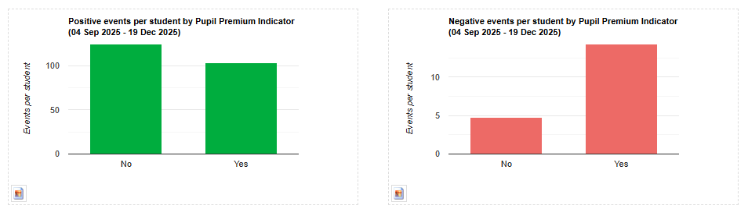  2024-25: Data analysis from this September shows that on average, non-disadvantaged pupils have a negative:positive behaviour score of 1:18, whereas with disadvantaged students that ratio is 1:10. When examining our suspension and internal isolation events for the academic year 24-25, when this strategy was written, 18 of the 42 children in school who had either been isolated or suspended were disadvantaged students, accounting for 43% of the total students who have been given a sanction of this nature – this group is clearly over-represented in this category.
4 | Attainment.  2025-26: KS3- When looking at average scores across all subjects, the attainment gap is most noticeable in Y9, especially among disadvantaged boys.  Looking specifically at English, Maths and Science, 18.6% of our identified students are falling well below the expected standard. But it is also worth noting that 11.6% are exceeding that standard.  KS4-In Year 11, the Attainment 8 score for PPG students is 32.24, this is over 1 whole grade lower than their peers (43.19 ALL, 46.45 Non-PP). 60% failed to achieve 5+ in both English and Maths and only 28% achieved 4+ in both subjects.  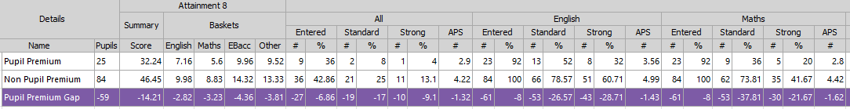  2024-25: Most recent data shows 36% of our identified disadvantaged students are not meeting expected progress in three or more subjects. This issue is particularly prevalent in Year 11 where 84% of disadvantaged students are under performing in three or more subjects. This attainment gap mirrors a stubborn national attainment gap between those from low income families are those who are not. Students may have significant gaps in their core knowledge, skills and understanding - especially in key areas such as reading - which in turn may lead to weaker progress across the curriculum. Our 24-25 Year 7 cohort arrived to us with 25% not meeting expected standard upon entry and 26% of those were identified as disadvantaged.
  KS3 | Average Scaled Score |  |  | Average Scaled Score PP |  |  | Average Scaled Score Non-PP
  KS3 | ALL | Male | Female | ALL | Male | Female | ALL | Male | Female
  Y7 | 100 | 97 | 102 | 97 | 96 | 98 | 101 | 97 | 104
  Y8 | 100 | 98 | 102 | 97 | 96 | 98 | 101 | 99 | 103
  Y9 | 100 | 95 | 105 | 94 | 89 | 102 | 102 | 97 | 106
5 | Well Being. Disadvantaged students who are persistently absent and/or have frequent sanctions of isolations/suspensions are more likely to suffer with issues relating to their wellbeing and mental health. This becomes a cycle of self-perpetuation where students feel increasingly isolated from the school community and in turn, feel less able or inclined to attend.
6 | Access to extra curricular opportunities. Due to financial restrictions, disadvantaged students may find it difficult to access extra-curricular activities or opportunities and may find it challenging to provide resources such as ingredients for food technology lessons.

Intended outcomes
This explains the outcomes we are aiming for by the end of our current strategy plan, and how we will measure whether they have been achieved.
Intended outcome | Success criteria
- Boost overall attendance, particularly among students receiving Pupil Premium (PP) funding, aiming to reduce absenteeism. | - Improved overall attendance, particularly a reduction in persistent absenteeism in disadvantaged students.
- Close the attainment gap between disadvantaged students and their peers. | - Disadvantaged students will make progress in line with or above their non-disadvantaged peers nationally.
- Support disadvantaged students with regards to their behaviour and wellbeing | - A reduction in suspensions and isolations in the disadvantaged student group. Students able to access support in a timely manner to support wellbeing.
- Ensure disadvantaged students can take advantage of breadth of opportunities at the school. | - Disadvantaged students accessing extra-curricular opportunities in line with their non-disadvantaged peers. Uptake in subjects like food tech in line with non-disadvantaged peers.

Activity in this academic year
This details how we intend to spend our pupil premium funding this academic year to address the challenges listed above.

Teaching (for example, CPD, recruitment and retention)
Budgeted cost: £ 31,225
Activity | Evidence that supports this approach | Challenge number(s) addressed
Review of curriculum materials to ensure an inclusive learning environment and accessibility for all and created to promote high aspirations with no curriculum narrowing.  Quality assurance of curriculum to ensure ambitious yet accessible to all. Classroom resources including access to assistive technology e.g., visualisers, tablets | Bridging the Word Gap at Transition. The Oxford Language report 2020  Closing the Vocabulary Gap- Alex Quigley, David Fulton Books, April 2018  Oral Language Interventions, Education Endowment Foundation Teaching and Learning Toolkit  Reading Comprehension Strategies, Education Endowment Foundation Teaching and Learning Toolkit  Using Digital Technology to Improve Learning Educational Endowment Foundation Guidance Report, August 2019. | 4, 3
Focus on increasing literacy skills of all students across the curriculum.  - ART (Centralised Trust Initiative)  - Raising profile of literacy, specifically SpaG with each department developing their own SpaG policy with explicit teaching interwoven in the curriculum.  - Weekly focus on oracy – all students take part at least once a week during targeted form-time activity. | Bridging the Word Gap at Transition. The Oxford Language report 2020  Closing the Vocabulary Gap- Alex Quigley, David Fulton Books, April 2018  Oral Language Interventions, Education Endowment Foundation Teaching and Learning Toolkit  Reading Comprehension Strategies, Education Endowment Foundation Teaching and Learning Toolkit | 1, 4
- High quality teacher training: Investing in professional development for teachers, focusing on evidence-based strategies to improve teaching quality; specifically metacognition, explicit instruction and retrieval practice. | High-quality teaching benefits all students (EEF: Effective Professional Development).  (EEF: Metacognition and Self-Regulated Learning).  Rosenshine’s Principles of Instruction and retrieval practice (EEF: Effective Professional Development). | 1, 4,

Targeted academic support (for example, tutoring, one-to-one support, structured interventions)
Budgeted cost: £ 31,225
Activity | Evidence that supports this approach | Challenge number(s) addressed
Peer Mentoring: Students in Years 10 and 11 are partnered with incoming Year 7 students and mentor them over the course of the academic year. This supports disadvantaged students with transition and wellbeing as well as providing positive role models | Peer tutoring | EEF (educationendowmentfoundation.org.uk) | 2, 5, 3
Targeted Literacy Support  Literacy Reading:  Fonetti Improving reading skills with Automatic Speech Recognition (ASR) and Real-Time Feedback  Spellzone Spelling Ability Test which creates a personal 'Course Pathway' and adapts according to new learning.  Speechlink identifies and supports with developmental speech sound difficulties.  Reading for pleasure. For pupils who have the reading skills and some comprehension skills but need to practice their reading skills for speed and accuracy.  Literacy Writing: Lexia. For identified pupils who need to develop their spelling and writing. | Reading comprehension strategies | EEF (educationendowmentfoundation.org.uk)  Lexia Reading Core5® | EEF | 1, 4
ELSA - 1:1 and small group activities with a focus on both self-esteem, emotion management and self-regulation ensuring that students understand themselves as learners and optimise their opportunities to learn in the classroom. | Mentoring | EEF (educationendowmentfoundation.org.uk)  Supporting the attainment of disadvantaged pupils - GOV.UK (www.gov.uk)

Wider strategies (for example, related to attendance, behaviour, wellbeing)
Budgeted cost: £80,000
Activity | Evidence that supports this approach | Challenge number(s) addressed
The pastoral team monitoring student's well-being and mental health. Pastoral support will include appropriate in-school support for example, wellbeing check-ins and external support where necessary.  - Ongoing feedback from student voice to identify students who require support.  - Strengthened communication between the school, students, and families.  - Introduction of support packages, with embedded evaluation measures to assess their effectiveness, using external resources when needed.  - Tackling barriers to school engagement caused by hardship or other challenges.  - Improved attendance through personalised pastoral support plans for students with persistent absenteeism. | Exploring the relationship between attendance and attainment - The University of Brighton  Summary of evidence | EEF :Addressing attendance barriers boosts attainment (EEF: Parental Engagement and Social and Emotional Learning). | 2, 3, 5, 6
Support for students to access extra curricula opportunities, funding for trips, resources etc | Access to extra-curricular provision and the association with outcomes - Education Policy Institute | 6

Total budgeted cost: £ 142,450.00

Part B: Review of the previous academic year

Outcomes for disadvantaged pupils
Strategy | Outcome
Lessen the attainment gap between PPG and non-PPG students. | Progress data for 2024-25 shows significant gains for disadvantaged students in KS3 where there are outperforming or in-line with their non-disadvantaged peers in nearly all English and Maths data sets.  Year 10 progress data 24-25:  All students:  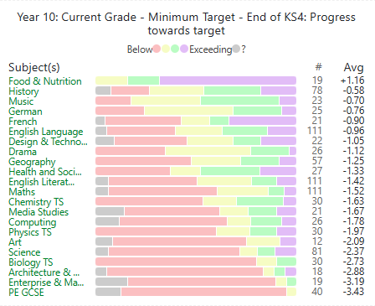  Disadvantaged students:  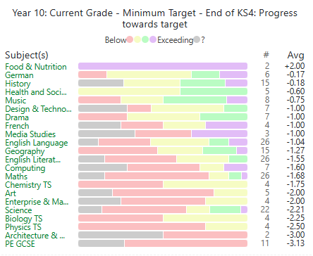  Year 9 progress data 24-25  All students:  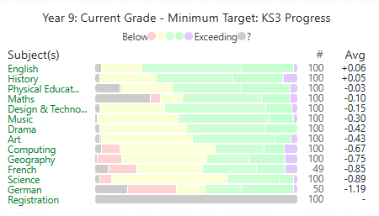  Disadvantaged students:  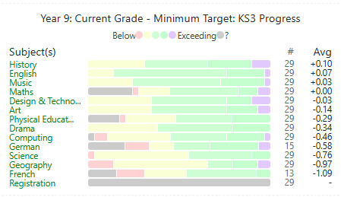  Year 8 progress data 24-25:  All students:  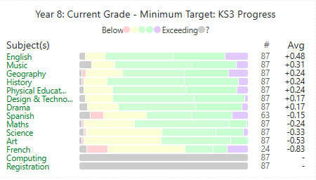  Disadvantaged students:  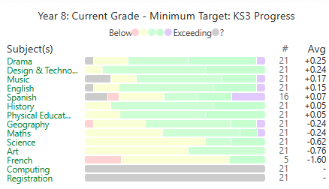  Year 7 progress data 24-25:  All students:  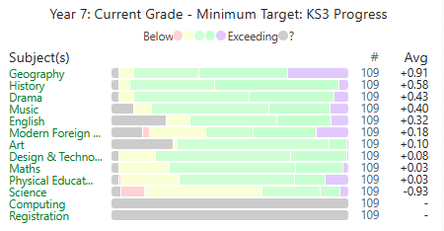  Disadvantaged students:  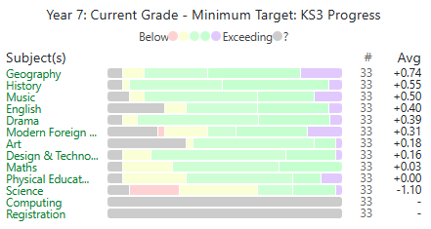  This outlines the impact of our Pupil Premium strategies on the 24-25 whole school cohort.
  2024-25 | Y7 | Y8 | Y9 | Y10 APS
  ENG - PP | +0.40 | +0.15 | +0.07 | 3.48
  All students | +0.32 | +0.48 | +0.06 | 4.29
  MATHS -PP | +0.03 | -0.24 | +0.00 | 2.78
  All students | +0.03 | -0.24 | -0.10 | 3.82

Externally provided programmes
Please include the names of any non-DfE programmes that you used your pupil premium to fund in the previous academic year.
Programme | Provider

